# Getting Started with ExcelMVC

Like Silverlight or WPF (Windows Presentation Foundation), ExcelMVC facilitates a clear separation between your application’s business objects (Models), its user interfaces (or Views) and its controllers (View Models). Welcome to the world of developing Excel applications using the MVVM ([more](http://en.wikipedia.org/wiki/Model_View_ViewModel)) pattern!

With ExcelMVC, you define your views in Excel (as opposed to in Xaml with Silverlight or WPF) and bind their view models implemented in any .NET language. Both your view models and your business objects are UI free. They can be bound to any UI that supports the MVVM pattern.

After you have been through this tutorial on ExcelMVC, you will see that developing Excel application with ExcelMVC is much simpler than developing their WPF or Silverlight equivalent ones, as you can rely on Excel doing the heavy lifting for most (if not all) of your applications’ UI requirements.

Can you imagine how difficult it would be to replicate some of the Excel UI functions, e.g. formatting, charting, printing, import / export etc., with WPF or Silverlight?

Can you also imagine with ExcelMVC, it becomes possible and easier to test your Excel applications? ExcelMVC removes the need of having complicated formulas and macros in your Excel workbooks.

So without further ado, let’s get started.

# Downloading the ExcelMVC sample applications

First let’s see what an ExcelMVC application looks like. Please just follow the steps below to run the FX spot trading application.

1. Click [here](http://sourceforge.net/projects/excelmvc/files/latest/download/ExcelMVC.1.4.5.zip) to download the latest ExcelMVC release and unzip the release to a folder on your local disk.
2. Go to the “samples\trading” folder, unblock all executable files (*.dll, *.xll and *.cmd). Right click on each file and select Properties to unblock a file.
3. Double click on the “Run.cmd” file to start the sample application. You will see an Excel screen showing below.
4. Click on “Start Auto-Deal” and “Start Simulation”, and you are on your way of making (or losing) loads money from the foreign exchange spot market.
5. Navigate to other tabs on the sheet to get a basic idea how ExcelMVC glues things together. Press Alt + F11 to see there is absolute no VB code behind.

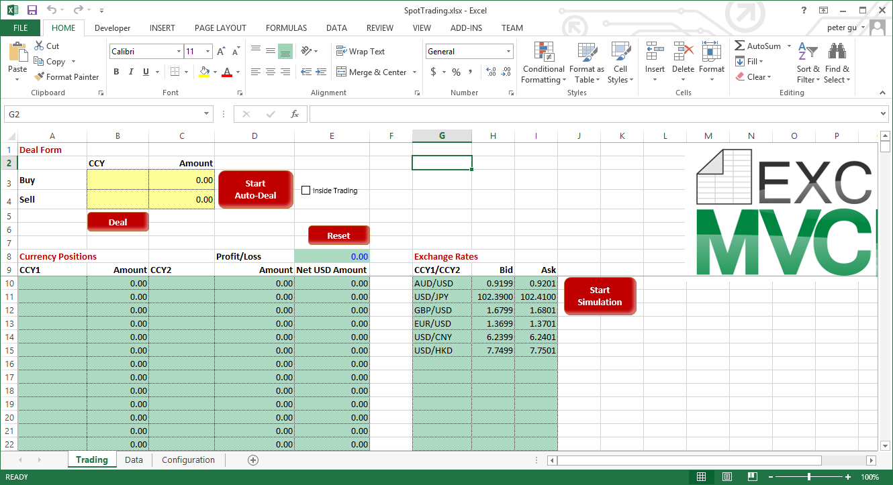

# Creating your first ExcelMVC project.

A typical ExcelMVC application is made up by two parts: the Application’s UI (one or more workbooks) and its logic behind (one or more .NET assemblies). Each part can be developed by different teams. For example expert Excel users can design the application’s workbooks, while professional .NET developers can prepare and test the application logic, independently if necessary. These two parts are glued together by ExcelMVC.

We will use the FX spot trading sample to work through the process of creating your first ExcelMVC project.

## Designing ExcelMVC workbooks

#### Identifying ExcelMVC workbooks

An ExcelMVC workbook is identified by a custom property “ExcelMVC” (Please note ExcelMVC string comparison is case insensitive).

The picture below shows the value of this property for the FX spot trading workbook (go to File | Properties | Advanced Properties).

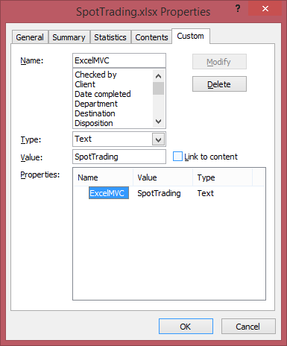

Later in this tutorial, you will see how ExcelMVC notifies you whenever a workbook is about to be opened in your Excel session. You use this ExcelMVC property to identify if a workbook belongs to your ExcelMVC application.

#### Defining ExcelMVC Forms and Tables

ExcelMVC currently supports two types of views, Form and Table. A form facilitates the binding between the properties of an object and Excel cells, while a table facilitates the binding between a collection of objects and Excel rows or columns.

Both views must be declared using Excel named ranges, which can be located anywhere in your workbook.

The name for an ExcelMVC form definition range must be in the form of “ExcelMVC.Form.X”, where X is the actual form name. The picture below shows the “Deal” form definition in the FX spot trading workbook.

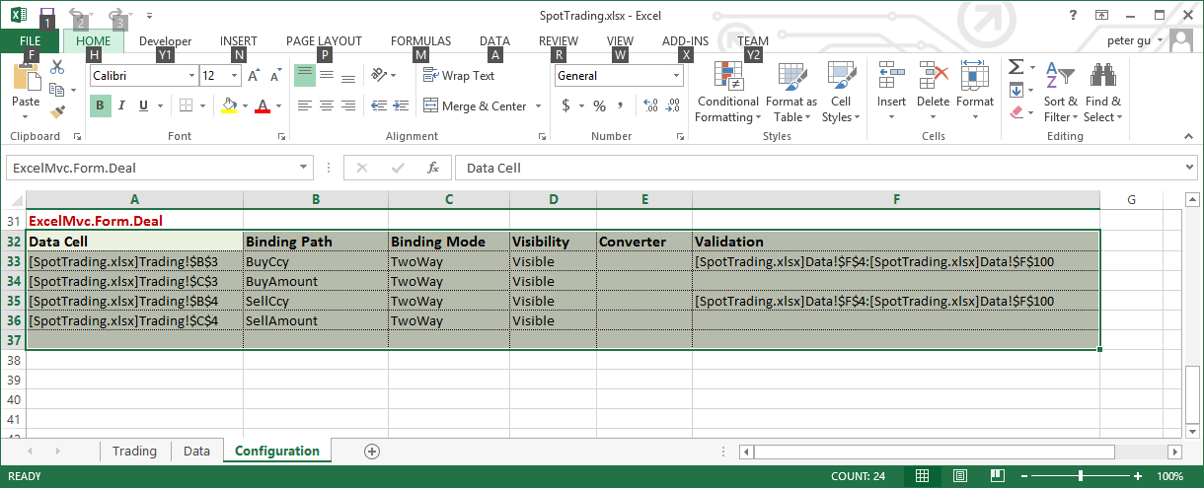

Similarly, the name for an ExcelMVC table definition range must be in the form of “ExcelMVC.Table.Y”, where Y is the actual table name. The picture below shows the “Positions” table definition in the FX spot trading workbook.

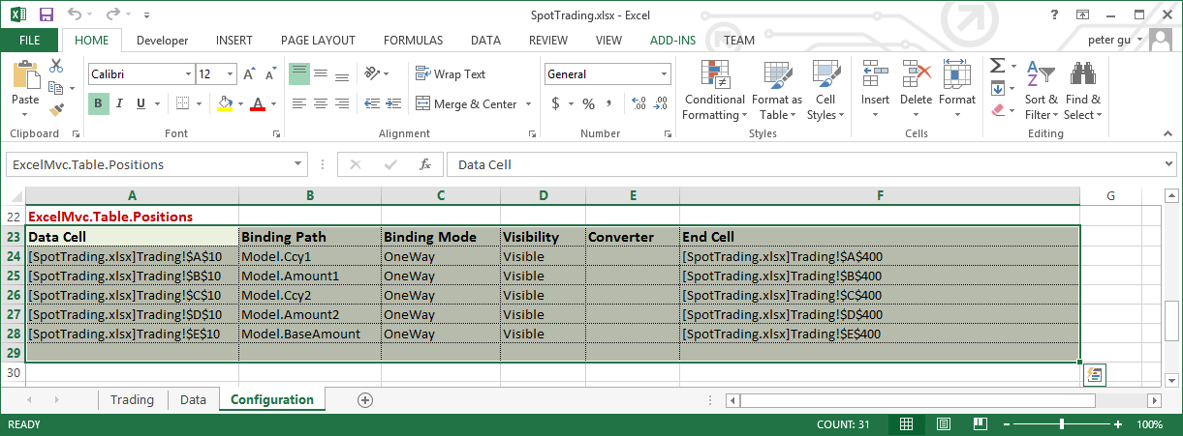

Each data row in a Form or Table definition range specifies a binding setting between a property of an object and an Excel cell.

The heading row in a definition range is what ExcelMVC uses to parse binding settings. The ordering of the headings is insignificant, but the actual heading text is significant. The following table lists headings required by ExcelMVC.

| **Heading** | **Purpose** |
| --- | --- |
| Data Cell | The address of the cell which the property specified by Binding Path is bound to.  Use Excel function CELL, e.g. “=CELL("address", Trading!A10)” to acquire an address string. |
| Data Path | The path to the property to be bound to the cell specified by Data Cell |
| Binding Mode | Determines how the binding is done between a view and its model. The following modes are supported:  **OneWay** – Properties on a model are displayed on the view to which the model is bound to. Changes made on a view is not updated to its model. This mode is primary for static views.  **OneWayToSource** – Values on a view are copied to the model to which the view is bound to. Changes made on a model is not displayed on its view. This mode is primary for static models with their properties sourced for Excel.  **TwoWay** – Properties on a model and values on its view are exchanged in both directions, model to view and view to model. |
| Visibility (Optional, default is True) | True or False, indicates the visibility of a table column (portrait) or table row (landscape). This setting does not apply for Forms. See below for supported table orientations. |
| Converter (Optional) | Specifies the converter (an instance of derived class System.Windows.Data.IValueConverter). The hosting assemblies of converters must be in the application base path. |
| Validation (Optional) | Specifies a range to be used as the Excel validation list of the cell.  Use Excel function CELL and CONCATENATE to specify a validation range string, e.g. =CONCATENATE(CELL("address", Data!F4), ":", CELL("address",Data!F100)) |
| End Cell (optional) | Specify the last cell a table view should be bound to. Without |